TATA MEMORIAL HOSPITAL
(TATA MEMORIAL CENTRE)
DR. ERNEST BORGES MARG
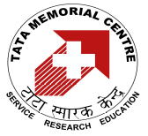PAREL, MUMBAI 400 012.

TENDER NO. : TMC/Diet/2015-2016
DATED : 14.01.2015

TENDER FOR THE SUPPLY OF ‘DIETARY ARTICLES’

FOR THE YEAR 2015-2016

FROM 1ST APRIL, 2015 TO 31ST MARCH, 2016

TENDER FEE: RS. 500/- (NON- REFUNDABLE)

LAST DATE OF TENDER SUBMISSION: 06TH FEBRUARY 2015 UPTO 4.30 P.M.

TECHNICAL BID OPENING: 9TH FEBRUARY, 2015 FROM 10.30 A.M. ONWARDS

